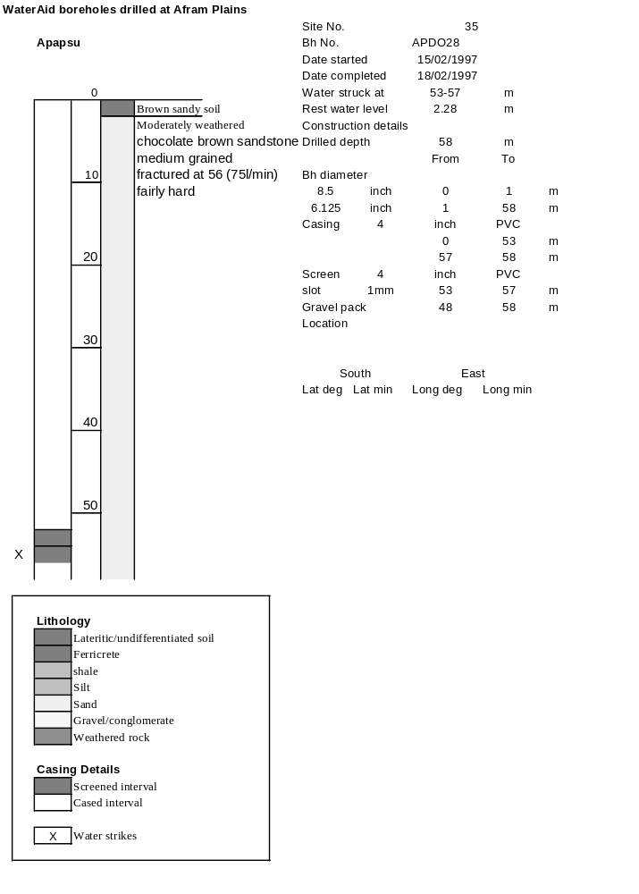

Ghana | Test pumping
Borehole No. |  | APDO 28
Hole No |  | 35
Village |  | Apapasu No.2
Date |  | 19/02/1997
Point above GL |  | 0.5 | m
Pump depth |  | 49 | m
SWL |  | 2.28 | m
Start Time |  | 09:15
Drawdown test |  |  |  |  | Recovery Test
time | pwl (m) | Q l/min | dd | sc(q/s) | Time | wl (m) | t/t' | resdd
0.00 | 2.28 | 60.00 | 0.00 |  | 0.00 | 32.70 |  | 30.42
1.00 | 10.42 | 60.00 | 8.14 | 7.37 | 1.00 | 24.34 | 181.00 | 22.06
2.00 | 15.52 | 60.00 | 13.24 | 4.53 | 2.00 | 17.62 | 91.00 | 15.34
3.00 | 19.00 | 60.00 | 16.72 | 3.59 | 3.00 | 12.33 | 61.00 | 10.05
4.00 | 21.12 | 60.00 | 18.84 | 3.18 | 4.00 | 8.25 | 46.00 | 5.97
5.00 | 22.68 | 60.00 | 20.40 | 2.94 | 5.00 | 5.23 | 37.00 | 2.95
6.00 | 24.00 | 60.00 | 21.72 | 2.76 | 6.00 | 3.58 | 31.00 | 1.30
7.00 | 25.00 | 60.00 | 22.72 | 2.64 | 7.00 | 2.89 | 26.71 | 0.61
8.00 | 25.86 | 60.00 | 23.58 | 2.54 | 8.00 | 2.71 | 23.50 | 0.43
9.00 | 26.55 | 60.00 | 24.27 | 2.47 | 9.00 | 2.70 | 21.00 | 0.42
10.00 | 27.08 | 60.00 | 24.80 | 2.42 | 10.00 | 2.69 | 19.00 | 0.41
11.00 | 27.51 | 60.00 | 25.23 | 2.38 | 12.00 | 2.68 | 16.00 | 0.40
12.00 | 27.84 | 60.00 | 25.56 | 2.35 | 14.00 | 2.68 | 13.86 | 0.40
13.00 | 28.13 | 60.00 | 25.85 | 2.32 | 16.00 | 2.67 | 12.25 | 0.39
14.00 | 28.32 | 60.00 | 26.04 | 2.30 | 18.00 | 2.67 | 11.00 | 0.39
15.00 | 28.50 | 60.00 | 26.22 | 2.29 | 20.00 | 2.66 | 10.00 | 0.38
16.00 | 28.66 | 60.00 | 26.38 | 2.27 | 22.00 | 2.66 | 9.18 | 0.38
17.00 | 28.79 | 60.00 | 26.51 | 2.26 | 24.00 | 2.66 | 8.50 | 0.38
18.00 | 28.90 | 60.00 | 26.62 | 2.25 | 26.00 | 2.65 | 7.92 | 0.37
19.00 | 29.05 | 60.00 | 26.77 | 2.24 | 28.00 | 2.65 | 7.43 | 0.37
20.00 | 29.17 | 60.00 | 26.89 | 2.23 | 30.00 | 2.65 | 7.00 | 0.37
22.00 | 29.34 | 60.00 | 27.06 | 2.22 | 35.00 | 2.65 | 6.14 | 0.37
24.00 | 29.42 | 60.00 | 27.14 | 2.21 | 40.00 | 2.64 | 5.50 | 0.36
26.00 | 29.44 | 60.00 | 27.16 | 2.21 | 45.00 | 2.64 | 5.00 | 0.36
28.00 | 29.49 | 60.00 | 27.21 | 2.21 | 50.00 | 2.64 | 4.60 | 0.36
30.00 | 29.61 | 60.00 | 27.33 | 2.20 | 60.00 | 2.64 | 4.00 | 0.36
35.00 | 29.68 | 60.00 | 27.40 | 2.19 | 70.00 | 2.63 | 3.57 | 0.35
40.00 | 29.77 | 60.00 | 27.49 | 2.18 | 80.00 | 2.63 | 3.25 | 0.35
45.00 | 29.79 | 60.00 | 27.51 | 2.18 | 90.00 | 2.62 | 3.00 | 0.34
50.00 | 29.84 | 60.00 | 27.56 | 2.18 | 100.00 | 2.62 | 2.80 | 0.34
55.00 | 30.00 | 60.00 | 27.72 | 2.16 | 110.00 | 2.62 | 2.64 | 0.34
60.00 | 30.10 | 60.00 | 27.82 | 2.16 | 120.00 | 2.61 | 2.50 | 0.33
70.00 | 30.09 | 60.00 | 27.81 | 2.16
80.00 | 31.10 | 65.00 | 28.82 | 2.26
90.00 | 31.21 | 65.00 | 28.93 | 2.25
100.00 | 31.36 | 65.00 | 29.08 | 2.24
110.00 | 31.59 | 65.00 | 29.31 | 2.22
120.00 | 31.73 | 65.00 | 29.45 | 2.21
130.00 | 31.91 | 65.00 | 29.63 | 2.19
140.00 | 32.10 | 65.00 | 29.82 | 2.18
160.00 | 32.43 | 65.00 | 30.15 | 2.16
180.00 | 32.70 | 65.00 | 30.42 | 2.14

